**SUMMER PROMOTION **

BOOK NOW!!!

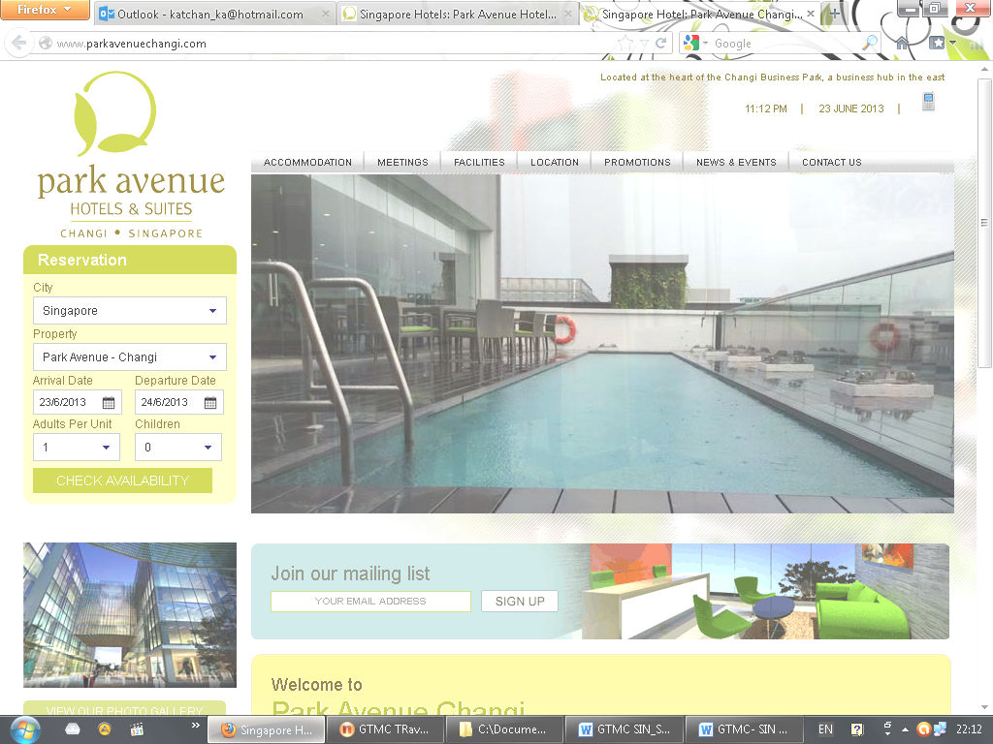
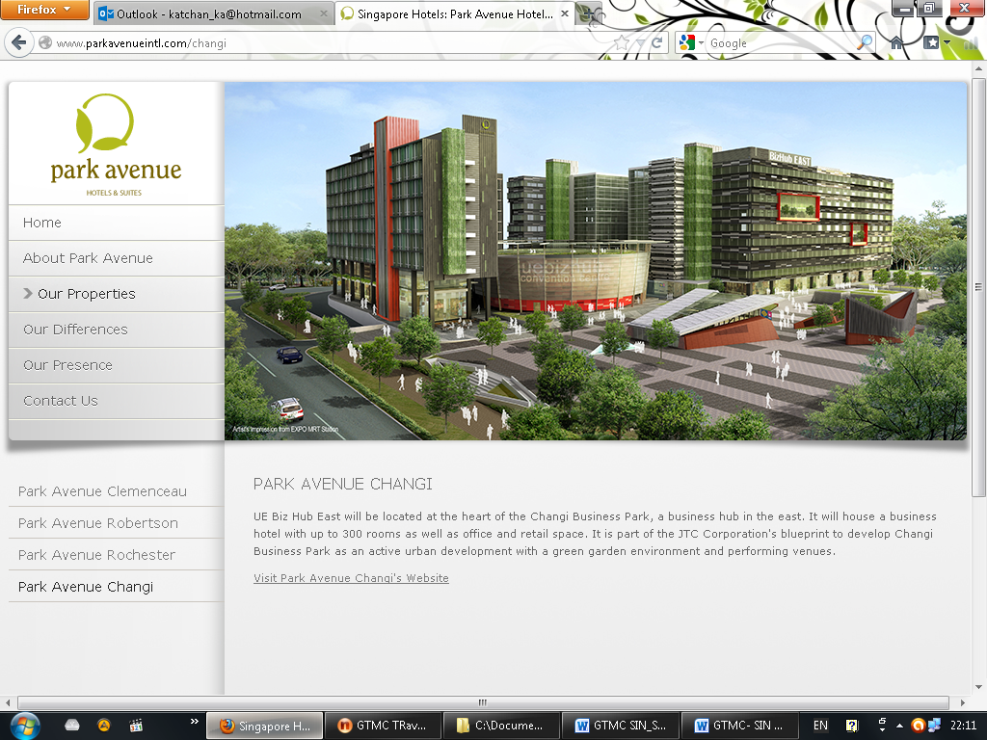
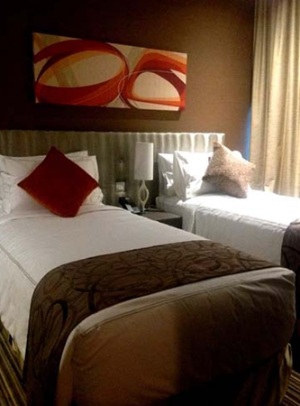
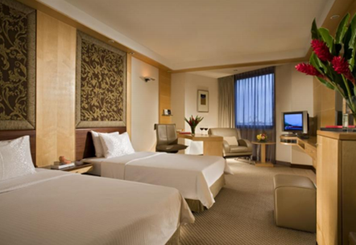
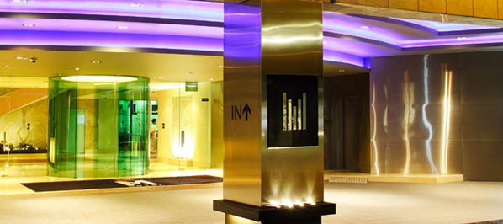


** Package Tour Rate for 3D2N **
Accommodation | Friday - Sunday | Monday - Thursday
Park Avenue Hotel Changi (4*) | SGD 210 | SGD 230
M Hotel (4*)  **financial area / Tanjong pagar** | SGD 225 | SGD 275
A Queen Hotel Lavender 3* | SGD 190 | SGD 190
Fragrance ImperialorSelegie 2* | SGD 160 | SGD 160
Parc Sovereign 3* | SGD 190 | SGD 190
Seacare Hotel 4* | SGD 220 | SGD 220
*** Park Avenue Hotel Changi (Superior Room) Effective 18 Jun – 31 Dec 2013 ***
*** M Hotel (Superior Room/No Extra Bed) Effective 01 Jul – 01 Sep 2013 ***

This prices are include : (Thai Market Only)
- 2 Nite accommodation with B’fast
- Round Trip Transfer APT-HTL-APT by SIC
- Halfday Singapore City tour by SIC
- No Extra bed

*** RATE ARE NOT APPLICABLE DURING SPECIAL EVEN FOR
COMMUNIC ASIA 17 - 21 JUNE 2013 & FOMULA ONE 19-22 SEP 2013 ***

